Longitudinal Section

Definition
# Source: AI Source: Provided by: [Data Path: Persons Table -> ID Column: 1, Name_En Column: Motasem Essam] -> From: [ChatGPT] on [7/25/2026]
A Longitudinal Section is a plane section obtained by cutting a three-dimensional solid with a plane that extends along its length, typically passing through its central axis or longitudinal direction.
For solids of revolution, a longitudinal section commonly refers to a section made by a plane containing the solid's axis of rotation. In this case, it is also called an Axial Section or, for a solid of revolution, a Meridian Section.
The resulting shape depends on the type of solid and the position of the cutting plane.
Important distinction:
- Longitudinal Section: A lengthwise section, which may or may not pass through the central axis, depending on the solid and context.
- Axial Section: A longitudinal section whose plane contains the central axis.
- Meridian Section: An axial section of a solid of revolution.

Geometric Representation
# Source: AI Source: Provided by: [Data Path: Persons Table -> ID Column: 1, Name_En Column: Motasem Essam] -> From: [ChatGPT] on [7/25/2026]
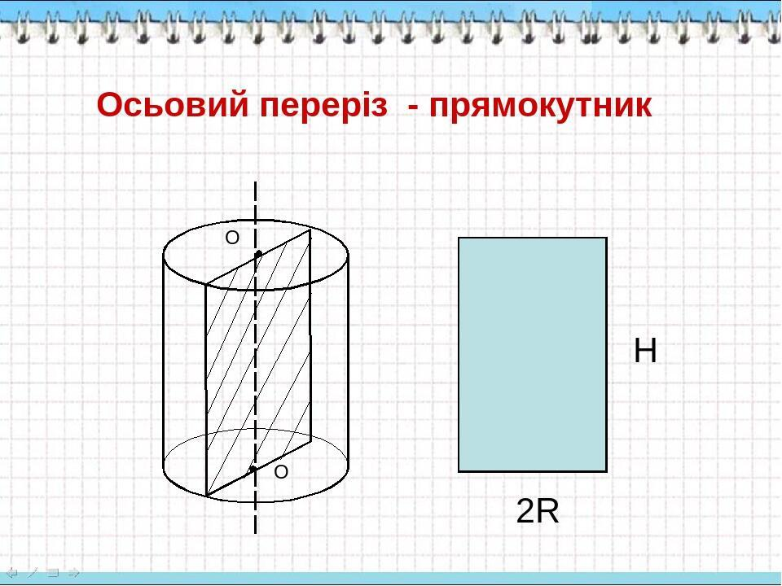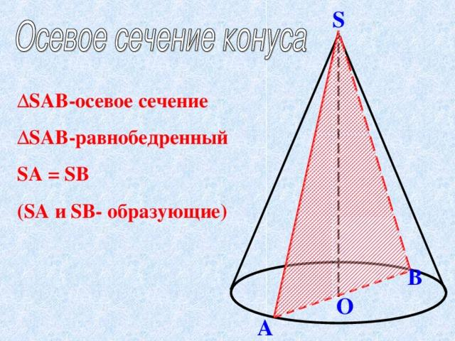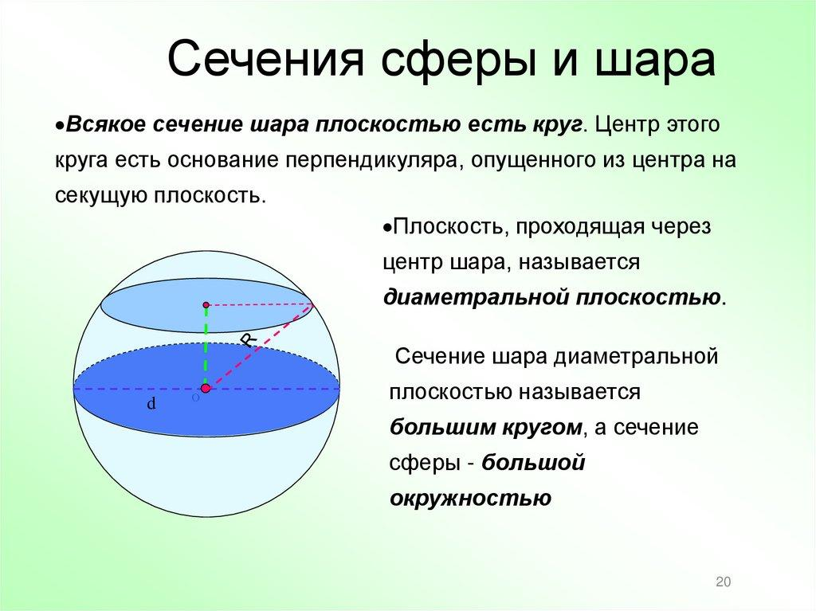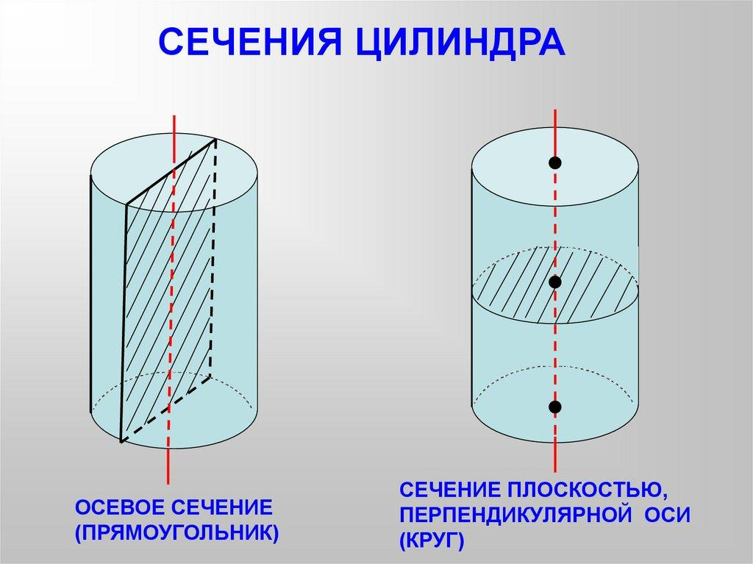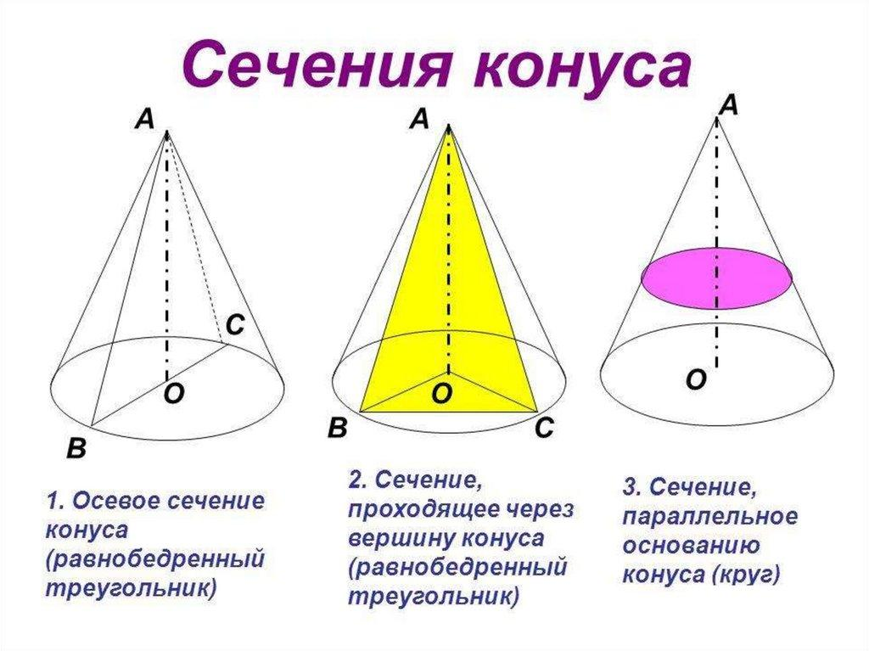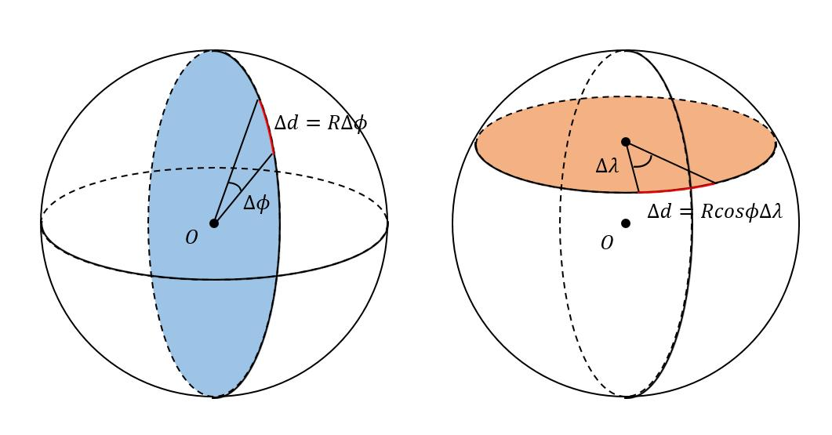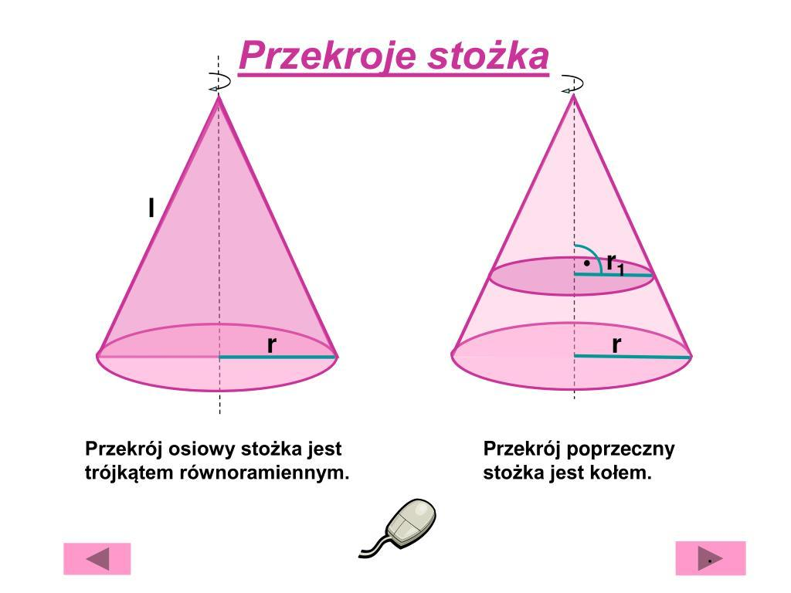
A longitudinal section is characterized by a cutting plane extending in the direction of the solid's length.
Its main geometric elements include:
- Solid: The three-dimensional object being sectioned.
- Longitudinal Direction: The direction along the length or axis of the solid.
- Cutting Plane: The plane passing lengthwise through the solid.
- Section Boundary: The outline created by the intersection.
- Section Region: The two-dimensional region enclosed by the boundary.
- Axis: The central reference line, when the section is axial.

Geometric Structure
# Source: AI Source: Provided by: [Data Path: Persons Table -> ID Column: 1, Name_En Column: Motasem Essam] -> From: [ChatGPT] on [7/25/2026]
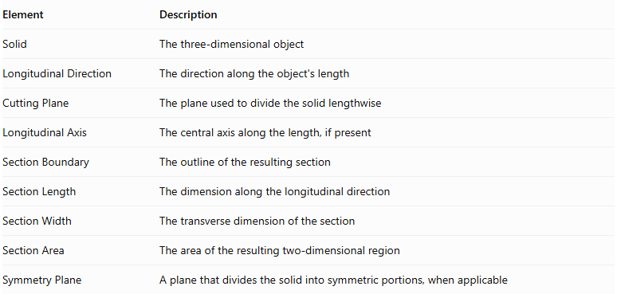
Element | Description
Solid | The three-dimensional object
Longitudinal Direction | The direction along the object's length
Cutting Plane | The plane used to divide the solid lengthwise
Longitudinal Axis | The central axis along the length, if present
Section Boundary | The outline of the resulting section
Section Length | The dimension along the longitudinal direction
Section Width | The transverse dimension of the section
Section Area | The area of the resulting two-dimensional region
Symmetry Plane | A plane that divides the solid into symmetric portions, when applicable

Main Characteristics
# Source: AI Source: Provided by: [Data Path: Persons Table -> ID Column: 1, Name_En Column: Motasem Essam] -> From: [ChatGPT] on [7/25/2026]
- The cutting plane extends along the longitudinal direction of the solid.
- It often passes through the central axis of a solid, producing an axial section.
- It reveals the internal lengthwise profile of a solid.
- Its shape depends on the solid's geometry.
- It may divide a solid into two equal or unequal portions.
- For symmetrical solids, a central longitudinal section may divide the solid into two congruent halves.
- For solids of revolution, an axial section passes through the axis of rotation.
- A longitudinal section is generally a two-dimensional region.

Types of Longitudinal Sections

According to Position Relative to the Axis
# Source: AI Source: Provided by: [Data Path: Persons Table -> ID Column: 1, Name_En Column: Motasem Essam] -> From: [ChatGPT] on [7/25/2026]
- Axial Longitudinal Section: The cutting plane contains the central axis.
- Off-Axis Longitudinal Section: The cutting plane extends lengthwise but does not contain the central axis.

According to Symmetry
# Source: AI Source: Provided by: [Data Path: Persons Table -> ID Column: 1, Name_En Column: Motasem Essam] -> From: [ChatGPT] on [7/25/2026]
- Symmetrical Longitudinal Section: The section divides the solid into two symmetric portions.
- Asymmetrical Longitudinal Section: The section does not divide the solid into two symmetric portions.

According to Geometric Shape
# Source: AI Source: Provided by: [Data Path: Persons Table -> ID Column: 1, Name_En Column: Motasem Essam] -> From: [ChatGPT] on [7/25/2026]
- Rectangular Longitudinal Section
- Triangular Longitudinal Section
- Trapezoidal Longitudinal Section
- Circular Longitudinal Section
- Elliptical Longitudinal Section
- Polygonal Longitudinal Section
- Irregular Curvilinear Longitudinal Section
These classifications describe different properties and can overlap. For example, an axial longitudinal section can also be rectangular and symmetrical.

Longitudinal Sections According to Solid Type

Cylinder
# Source: AI Source: Provided by: [Data Path: Persons Table -> ID Column: 1, Name_En Column: Motasem Essam] -> From: [ChatGPT] on [7/25/2026]
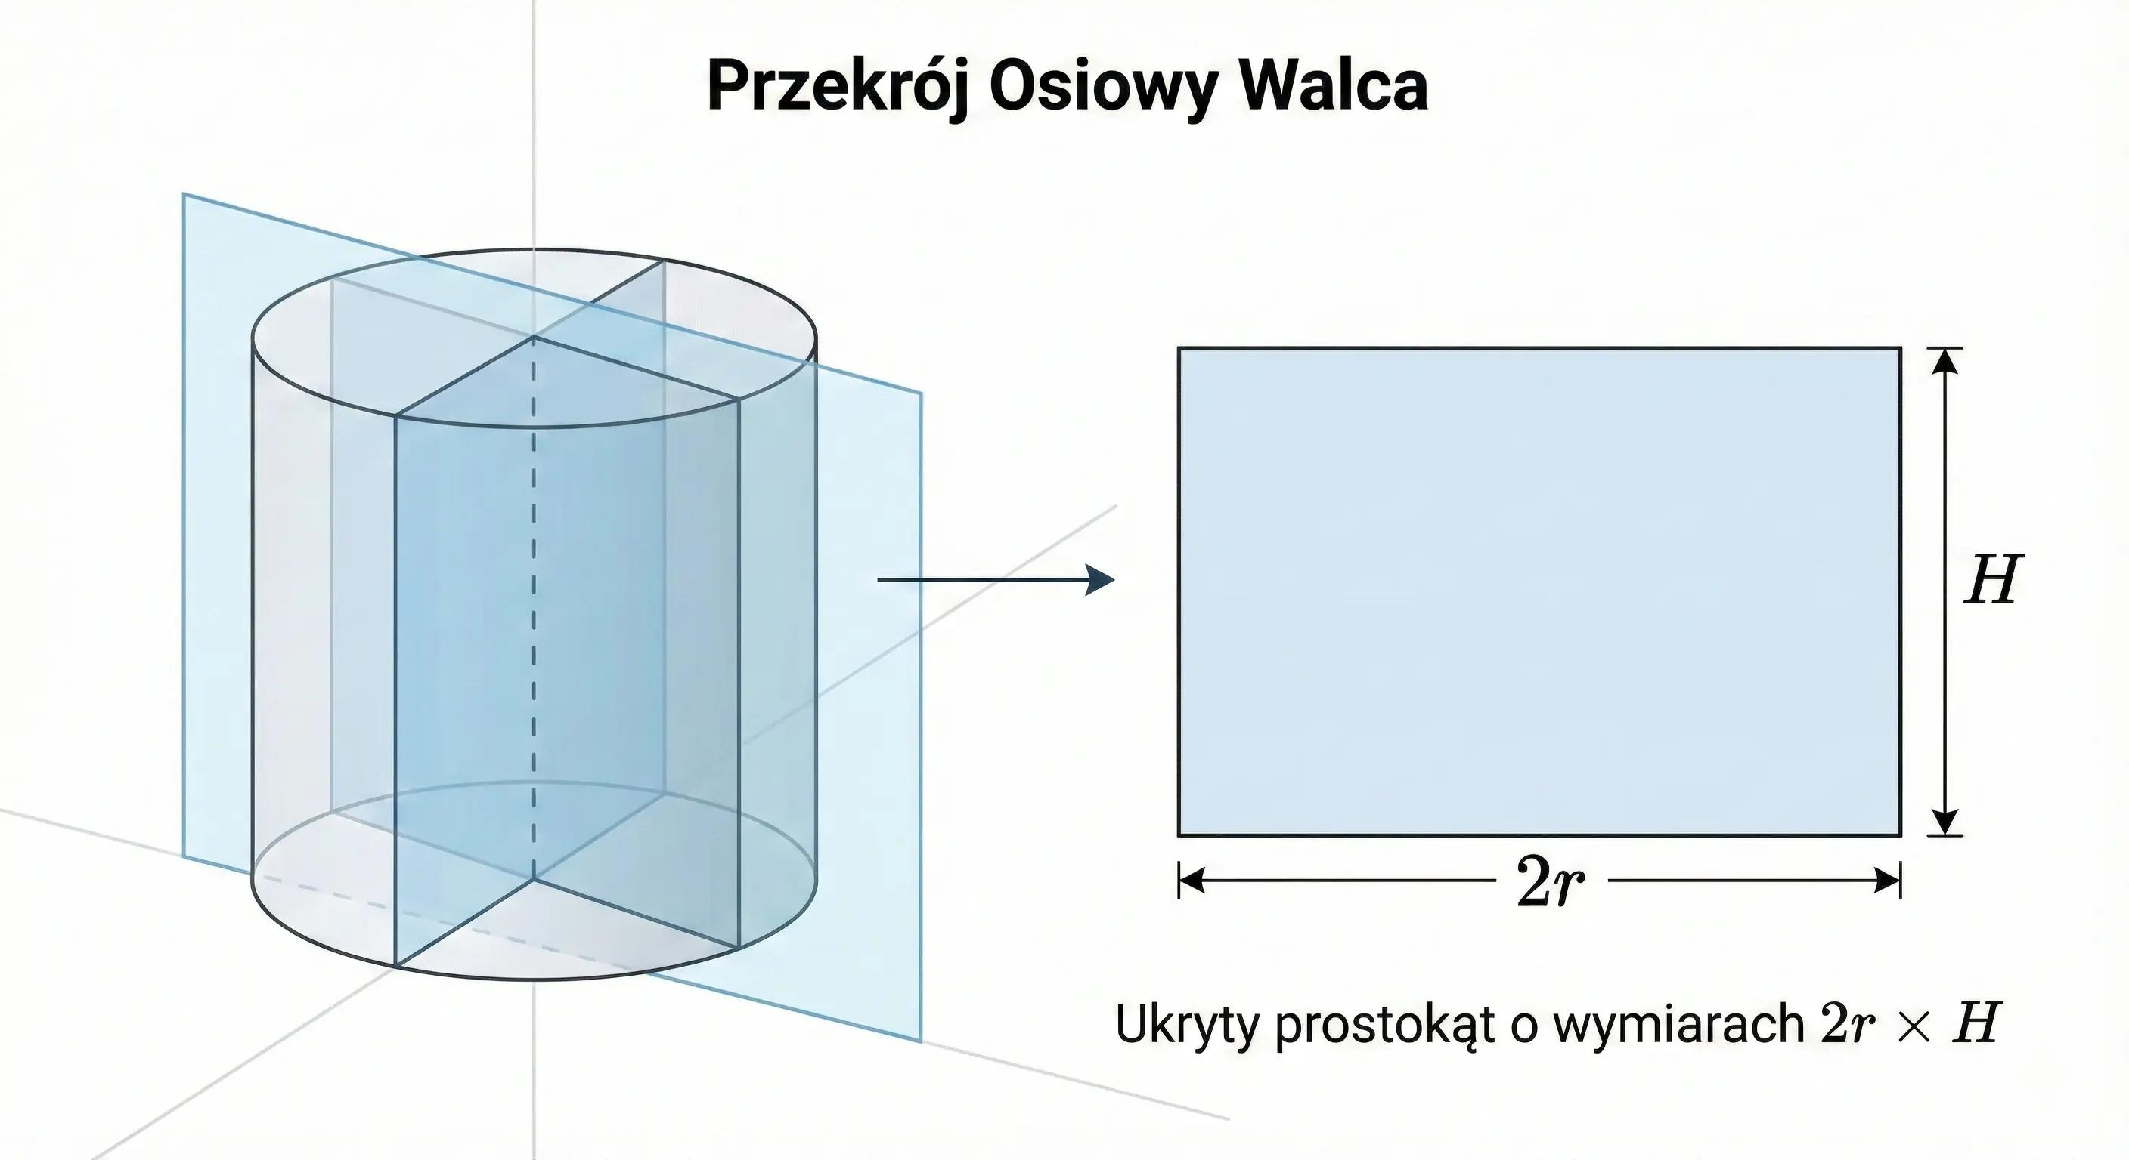
For a right circular cylinder, a plane passing through its central axis produces a rectangle.
- Width: Diameter of the base.
- Length: Height of the cylinder.
$$A=2rh$$
Where:
- $r$: Radius of the base.
- $h$: Height of the cylinder.
The rectangle has dimensions $2r×h$.

Cone
# Source: AI Source: Provided by: [Data Path: Persons Table -> ID Column: 1, Name_En Column: Motasem Essam] -> From: [ChatGPT] on [7/25/2026]
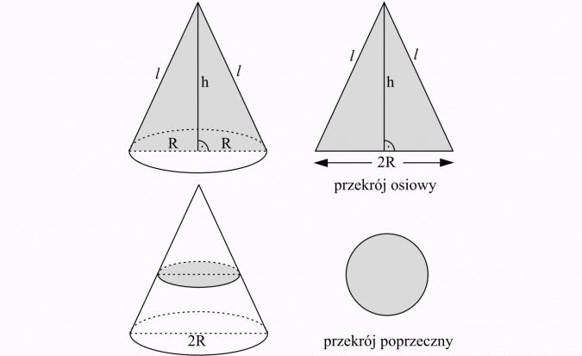
For a right circular cone, a plane passing through its axis and vertex produces an isosceles triangle.
- Base: Diameter of the circular base.
- Height: Height of the cone.
- Equal sides: Slant heights.
$$A=\frac{1}{2}(2r)h=rh$$
Where:
- $r$: Base radius.
- $h$: Cone height.

Sphere
# Source: AI Source: Provided by: [Data Path: Persons Table -> ID Column: 1, Name_En Column: Motasem Essam] -> From: [ChatGPT] on [7/25/2026]
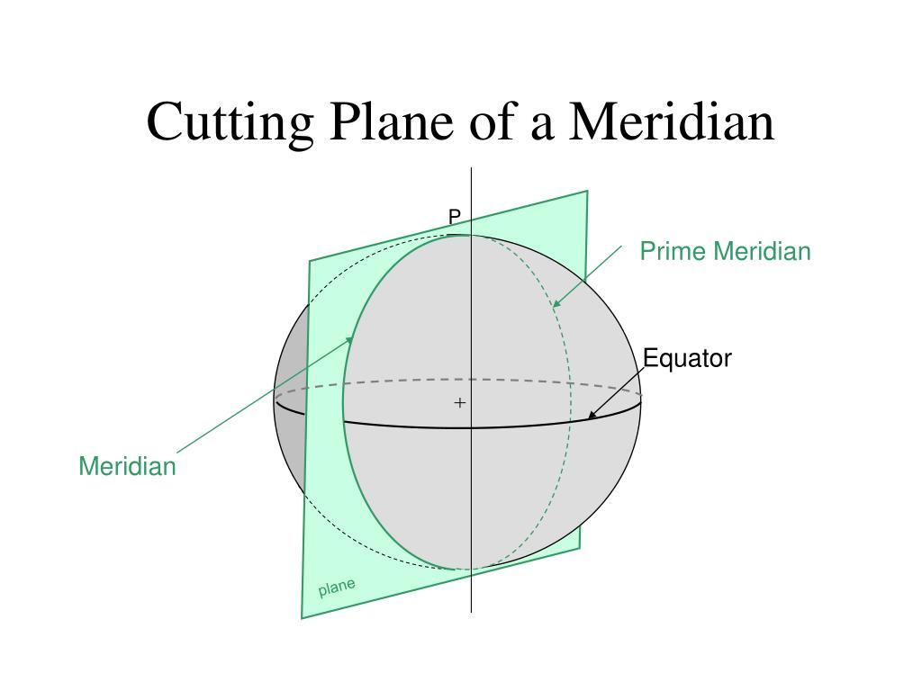
For a sphere, a plane passing through its center produces a great circle.
$$A=πR^{2}$$
Where $R$ is the sphere's radius.
The section boundary is a circle, and the section is a circular disk.

Prism
# Source: AI Source: Provided by: [Data Path: Persons Table -> ID Column: 1, Name_En Column: Motasem Essam] -> From: [ChatGPT] on [7/25/2026]
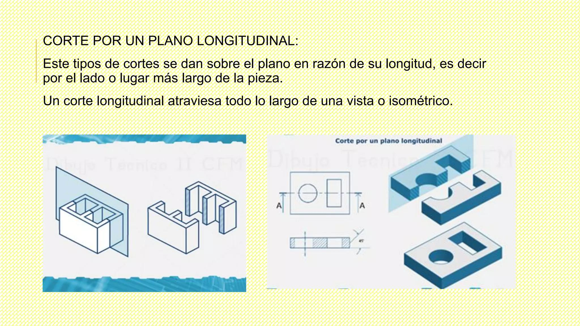
For a right prism, a longitudinal plane parallel to its lateral edges can produce a rectangular or polygonal section, depending on the base and the position of the plane.
For a right rectangular prism, a central longitudinal section parallel to a pair of lateral edges produces a rectangle.

Pyramid
# Source: AI Source: Provided by: [Data Path: Persons Table -> ID Column: 1, Name_En Column: Motasem Essam] -> From: [ChatGPT] on [7/25/2026]
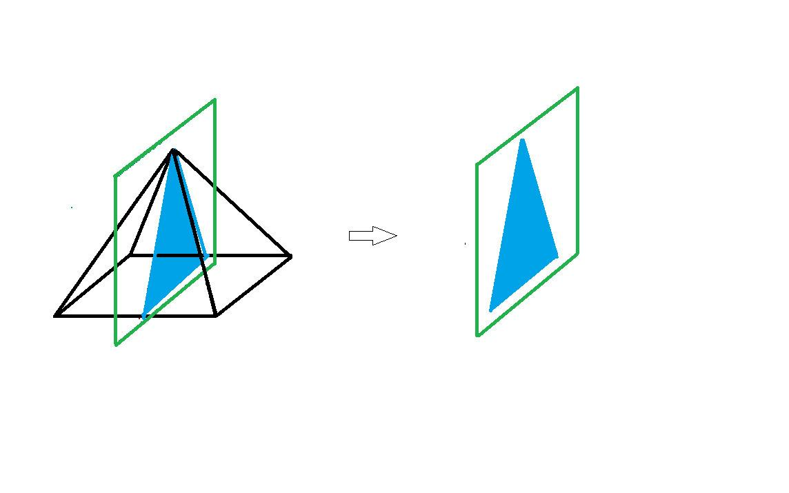
For a right regular pyramid, a plane passing through the apex and the center of its base produces a triangular section when it intersects the base along a line joining opposite points of the base boundary.
For a square pyramid, this section is an isosceles triangle.

Torus
# Source: AI Source: Provided by: [Data Path: Persons Table -> ID Column: 1, Name_En Column: Motasem Essam] -> From: [ChatGPT] on [7/25/2026]
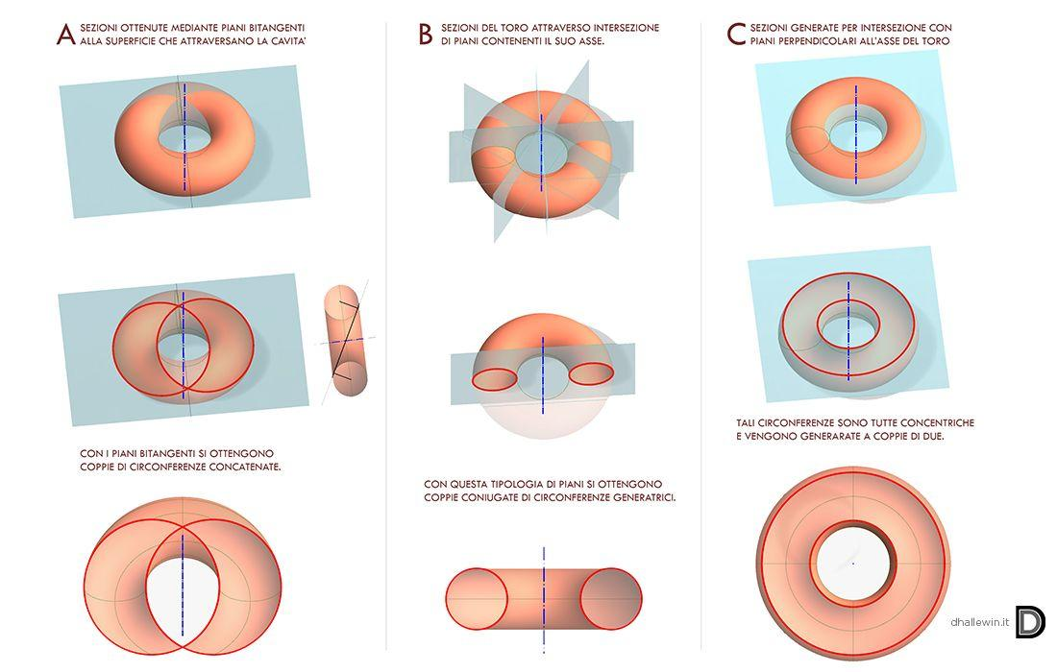
For a ring torus, a vertical plane passing through its central axis produces two separate circular regions.
This is an example of a longitudinal axial section that has multiple connected components.

Mathematical Representation

General Plane Equation
# Source: AI Source: Provided by: [Data Path: Persons Table -> ID Column: 1, Name_En Column: Motasem Essam] -> From: [ChatGPT] on [7/25/2026]
A longitudinal section is represented using a plane equation:
$$ax+by+cz+d=0$$
For a solid whose longitudinal axis is the $z$-axis, an axial plane must contain the $z$-axis.
A plane containing that axis can be written as:
$$ax+by=0$$

Section as an Intersection
# Source: AI Source: Provided by: [Data Path: Persons Table -> ID Column: 1, Name_En Column: Motasem Essam] -> From: [ChatGPT] on [7/25/2026]
Let:
- $S$: Three-dimensional solid.
- $P$: Longitudinal cutting plane.
- $C$: Resulting longitudinal section.
Then:
$$C=S∩P$$

Common Section Area Formulas
# Source: AI Source: Provided by: [Data Path: Persons Table -> ID Column: 1, Name_En Column: Motasem Essam] -> From: [ChatGPT] on [7/25/2026]
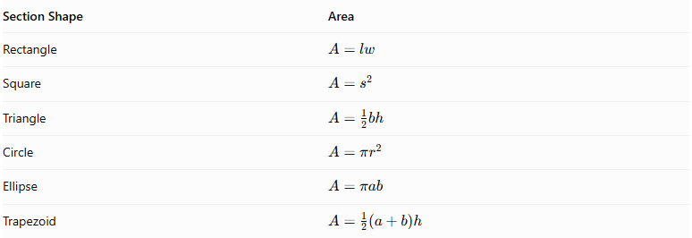
Section Shape | Area
Rectangle | $$A=lw$$
Square | $$A=s^{2}$$
Triangle | $$A=\frac{1}{2}bh$$
Circle | $$A=πr^{2}$$
Ellipse | $$A=πab$$
Trapezoid | $$A=\frac{1}{2}(a+b)h$$

Comparison with Related Sections
# Source: AI Source: Provided by: [Data Path: Persons Table -> ID Column: 1, Name_En Column: Motasem Essam] -> From: [ChatGPT] on [7/25/2026]
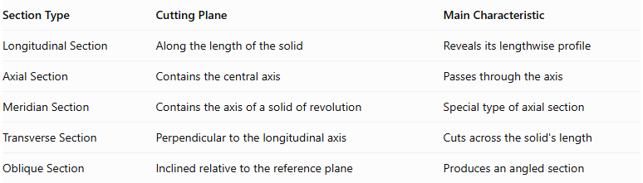
Section Type | Cutting Plane | Main Characteristic
Longitudinal Section | Along the length of the solid | Reveals its lengthwise profile
Axial Section | Contains the central axis | Passes through the axis
Meridian Section | Contains the axis of a solid of revolution | Special type of axial section
Transverse Section | Perpendicular to the longitudinal axis | Cuts across the solid's length
Oblique Section | Inclined relative to the reference plane | Produces an angled section

Applications
# Source: AI Source: Provided by: [Data Path: Persons Table -> ID Column: 1, Name_En Column: Motasem Essam] -> From: [ChatGPT] on [7/25/2026]
- Engineering: Examining the internal lengthwise structure of mechanical components.
- Architecture: Representing vertical or lengthwise cuts through buildings.
- Manufacturing: Inspecting the internal structure of cylindrical and mechanical parts.
- Mechanical Design: Studying the axial profiles of shafts, pipes, cones, and rotating components.
- Technical Drawing: Representing internal features that cannot be seen from external views.
- Mathematics: Studying the relationship between solid geometry and plane sections.

Main Classification
# Source: AI Source: Provided by: [Data Path: Persons Table -> ID Column: 1, Name_En Column: Motasem Essam] -> From: [ChatGPT] on [7/25/2026]
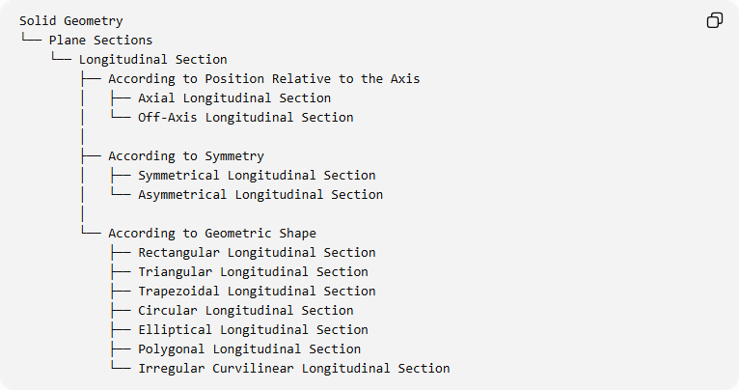
Solid Geometry
└── Plane Sections
└── Longitudinal Section
├── According to Position Relative to the Axis
│ ├── Axial Longitudinal Section
│ └── Off-Axis Longitudinal Section
│
├── According to Symmetry
│ ├── Symmetrical Longitudinal Section
│ └── Asymmetrical Longitudinal Section
│
└── According to Geometric Shape
├── Rectangular Longitudinal Section
├── Triangular Longitudinal Section
├── Trapezoidal Longitudinal Section
├── Circular Longitudinal Section
├── Elliptical Longitudinal Section
├── Polygonal Longitudinal Section
└── Irregular Curvilinear Longitudinal Section

Key Points
# Source: AI Source: Provided by: [Data Path: Persons Table -> ID Column: 1, Name_En Column: Motasem Essam] -> From: [ChatGPT] on [7/25/2026]
- A longitudinal section is produced by cutting a solid along its length.
- An axial longitudinal section passes through the solid's central axis.
- For solids of revolution, an axial longitudinal section is also called a meridian section.
- A cylinder produces a rectangular axial section.
- A cone produces a triangular axial section.
- A sphere produces a circular axial section.
- A torus can produce a section consisting of two separate circular regions.
- Longitudinal sections are useful for studying the internal geometry and lengthwise structure of solids.

Conclusion
# Source: AI Source: Provided by: [Data Path: Persons Table -> ID Column: 1, Name_En Column: Motasem Essam] -> From: [ChatGPT] on [7/25/2026]
A Longitudinal Section is an important type of plane section used to examine the lengthwise geometry of three-dimensional solids. When the cutting plane passes through the central axis, it forms an axial section. In solids of revolution, this is specifically known as a meridian section. Its resulting shape varies according to the solid's geometric structure and the position of the cutting plane.

Sources
# Source: AI Source: Provided by: [Data Path: Persons Table -> ID Column: 1, Name_En Column: Motasem Essam] -> From: [ChatGPT] on [7/25/2026]
- Descriptive Geometry – Sections and Meridian Sections
- Axial Sections of Cylinders, Cones, and Spheres
- Solid Geometry – Longitudinal Sections of a Cylinder
- Khan Academy – Solid Geometry Vocabulary

